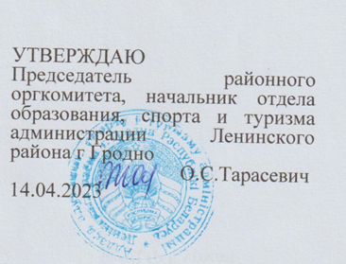

Situations for discussion 7th Form
- There are a lot of travel options. Why and where do people travel? Speak about travelling.
- What are the advantages of a hop on / hop off bus tour?
- Do you prefer window seats or aisle sits? Why?
- Is it important to make up a travel itinerary before going on a journey?
- How often do you go on school outings?
- Where do you think you will go on holidays?

- Belarus is a beautiful country with its own unique history, nature and people. Speak about Belarus.
- Are you proud of Belarus?
- What is the symbol of Belarus in your opinion?
- What holidays do people celebrate in Belarus?
- Are there any places of interest in your native town?
- What is your country famous for?

3. Nobody knows you better than you yourself. Speak about yourself.
- What is your favourite thing to do at the weekend?
- What do you want to be when you get older? Why?
- What makes you smile?
- What do you like doing together with your parents?
- Do you think that you are a good person?

4. Sport helps people to be healthy and fit. It is sometimes difficult to choose a kind of sport to do. Speak about the role of sport in your life.
- What are the most popular kinds of sport in your country?
- Do you enjoy watching sports?
- Does healthy food help you to keep fit?
- What sport facilities do you have in your neighbourhood?
- What kind of sport would you like to take up?

5. London is so popular among tourists. What sights of London attract people from all over the world? Speak about London.
1. What landmark can be called the symbol of London?
2. Is it a good idea to explore London on foot?
3. What is the most interesting fact about London in your opinion?
4. What London sight would you like to visit most of all?
5. Would you like to live in such a big city?

6. Imagine you are telling your British friend about your native town. What would you tell about?
1. What things do you like about your native place?
2. What is your town famous for?

3. What is your favourite place in your town? Why?
4. What sights in your native town are worth visiting?
5. What are the advantages of living in the city?

7. Some people say that Belarusian people are the nation of shoppers. What kinds of shops are there in Belarus?
1. Do you agree that shopping is a kind of entertainment?
2. Who are shopaholics?
3. Are small corner shops still popular?
4. Do you enjoy shopping for food or clothes?
5. Window shopping is exciting, isn’t it?

8. Imagine that you are making a speech at the conference about your school. Speak about your school?
1. What subjects are you good at?
2. Do you think a school uniform is a good idea?
3. Is bulling a huge problem nowadays?
- How much time do you spend on your homework?
- What do your classmates do during the breaks?
9. Hobbies differ like tastes. What is your hobby? Speak about it.
1. Can people make money from doing hobbies?
2. Is it possible to live without hobbies?
3. What hobbies do your parents have?
4. What unusual hobbies do you know?
5. What hobby would you like to take up in future?

10. We can’t imagine our life without friends and friendship. What role do friends play in your life?
1. Do you have a good friend among adults?
2. Do you have much in common with your friend?
3. Is it a good idea to make friends on the internet?
4. What personality traits do you hate in people?
5. Are you a good friend?

